Project Powerlift Final Analysis:

Powerlifting is the sport of lifting heavy weights in three different ways from a standing or lying position, but without lifting the weights above the head.

It consists of three lifts: the squat, the bench press and deadlift. In this project, our goal is to obtain a large database, and clean the data to find relationships.

In doing so, we are seeking to answer the following questions:

- Does age have a correlation with performance in powerlifting competitions? Our initial thoughts would be that younger athletes would have a higher likeliness of succeeding in

competition, but the data may suggest otherwise. Is it possible that adults in their 30s and 40s could begin taking training more seriously, and getting ready

for competitions more effectively? Is there a prime age? and could this prime age be different between genders?

- This leads to our next question of a relationship between genders in powerlifting competitions. In this project, we are looking to answer questions about how each gender performs across

different age and weight ranges. One question we had early was related to the disparities in participation of certain weight classes between both genders, and whether this may impact the

results when looking for correlation. Also, are there similar results between men and women of similar weight? and does this change at different age ranges?

- Lastly, we want to understand the relationship of body weight with powerlifting. On the surface we would hypothesize that bigger lifters would be able to lift more weight, but does this

theory hold truth when we look at the data? It's worth asking, does body weight correlated to overall strength, and if so, at which weight range does that advantage start to taper?

Does having more weight carry the same effectiveness across both genders? and at all age ranges? Cleaning the data to show relationships of weight over different ages and amongst both

genders competing could show contrary results to original beliefs.

Results:

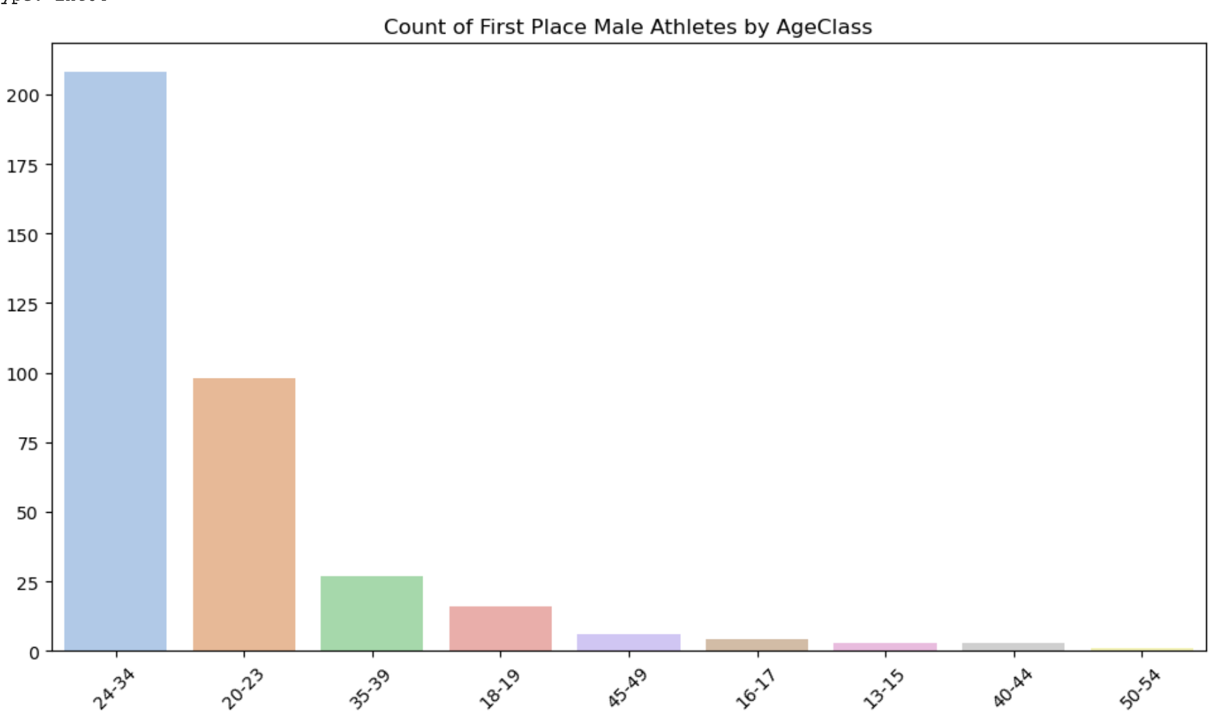

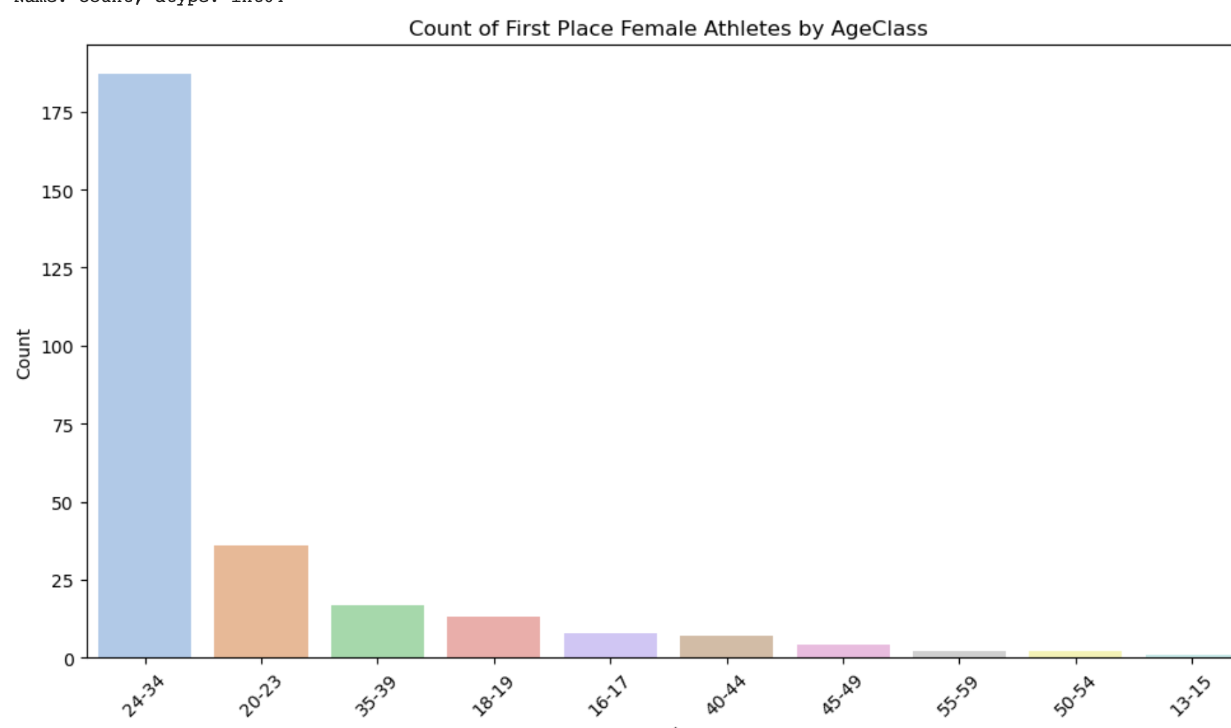

For this task, we used the data to find all winners of competitions, and sorted those winners into age ranges. The results show a clear prime age, as 208 of the 355 winners for men, and 187 of the 261 women were in the age range 24-34. Overall, almost all winners are between the ages of 20-34. One difference in the data between males and females would be the age range with the least number of winners. For males this occurs at older ages with a range of 50-54, showing they may show signs of muscles regressing after a certain point in their life. For females, their lowest first places occur at a very early age range. There are many reasons this may be the case, but we figured this may be due to lack of experience, and it could be possible that female competitions could rely more on form and technique over raw ability.

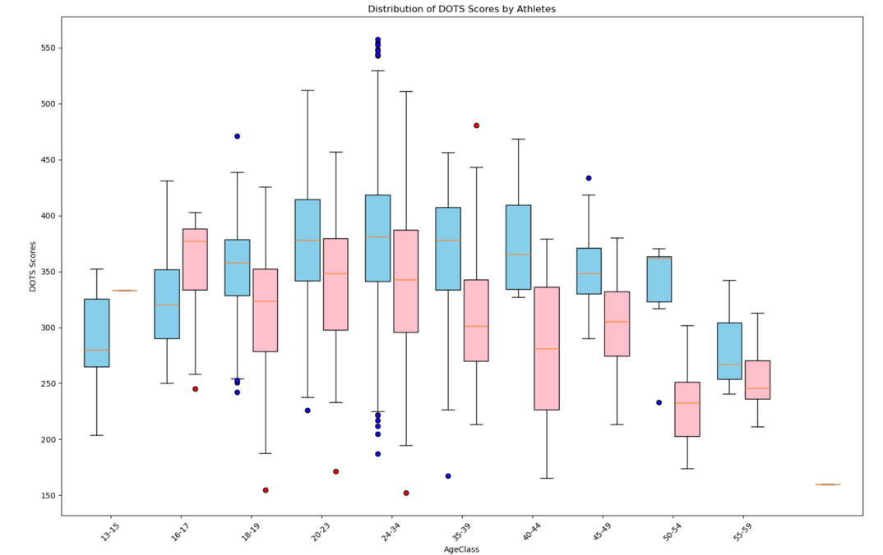

In this diagram, we use boxplots to visualize averages of male and female lifters across different age ranges. For the y-axis, we use DOTS score, which is a metric for competition that calculates the amount lifted as a ratio to the lifter’s bodyweight. Here we can see that most lifters seem to peak at the age ranges of 20-39, and slowly the amount lifted descends as the lifters age increases. One surprise is the number of outliers at what one might consider a prime age range of 24-34. It makes sense that the mean DOTS score appears to be the highest in this range, but this doesn’t answer why there is such a large variance between lifters. In the end, we concluded this may be the case because while this may be some lifters prime, it also may be when people begin exploring powerlifting, and lifting in competitions. Because of this, the mean may be brought down, showing high outliers due to those who’ve had experience, and are in peak physical condition, while also having outliers on the low side who may be still figuring out technique and proper training.

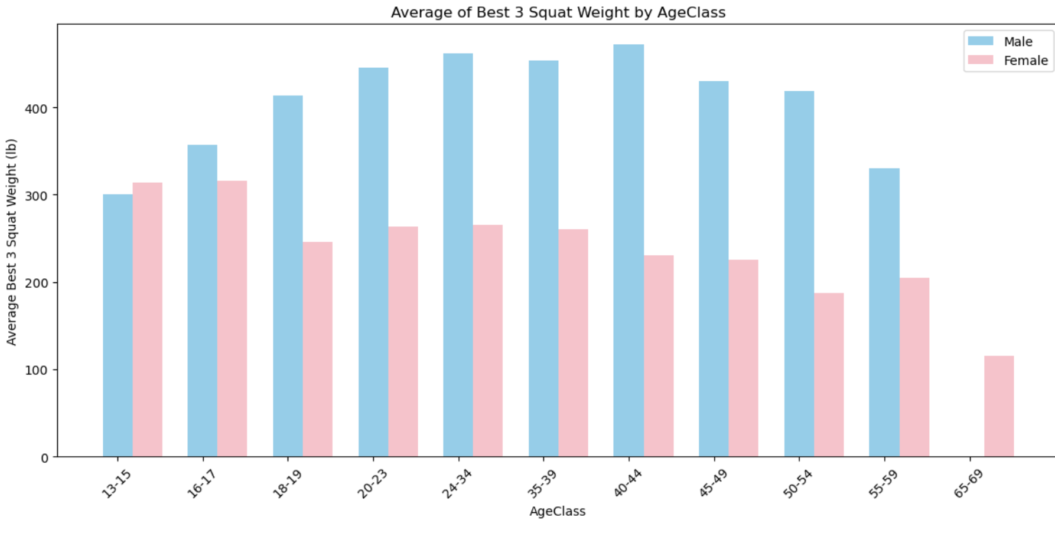

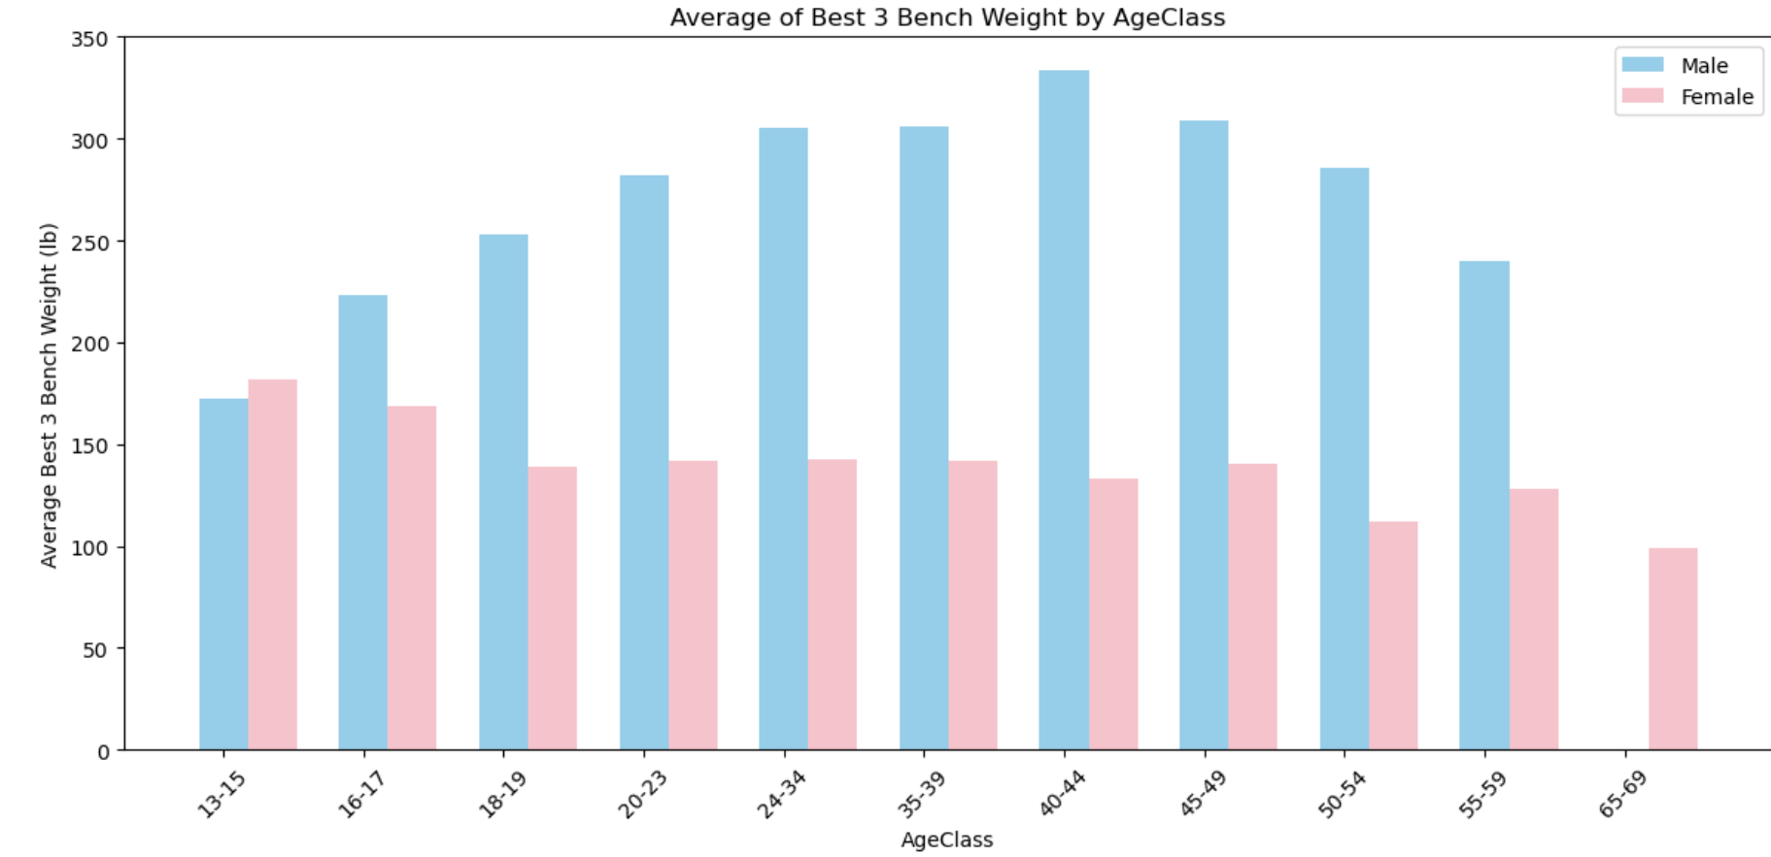

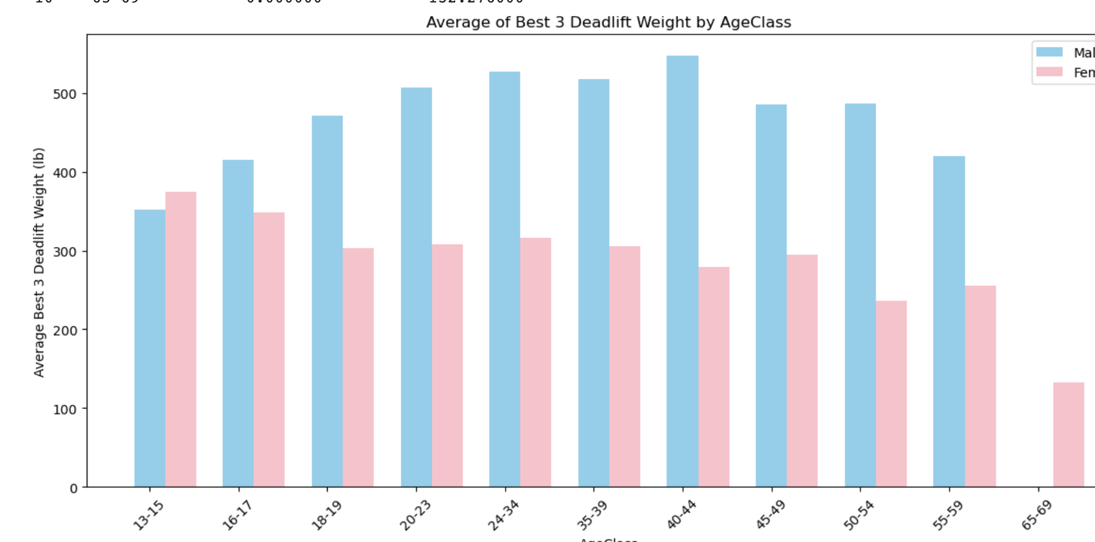

Here, we look at the best 3 results for each of the three lifts, across both genders. What’s interesting here is that the female competitors appear to outlift males both early, and later in life, but in the years 16-59, males are outlifting by a fair amount. There’s many reasons we may be seeing this, as it may show signs that females develop earlier than males, and may have higher longevity in later years, but overall on average for almost all age ranges, male’s lift the most weight.

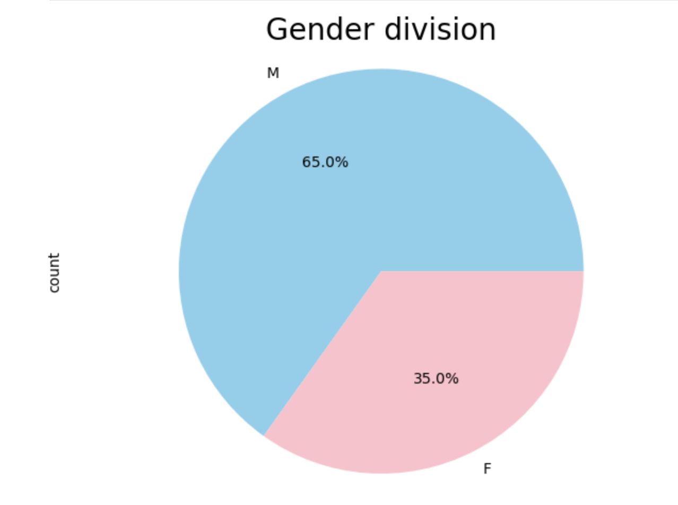

It’s important to know the sample size we are working with in the data. For this dataset, a majority of competitors are male (65%). Because of the smaller sample size of females, it’s important to note disparities in certain areas, such as female representation in higher weight classes, or in certain age ranges.

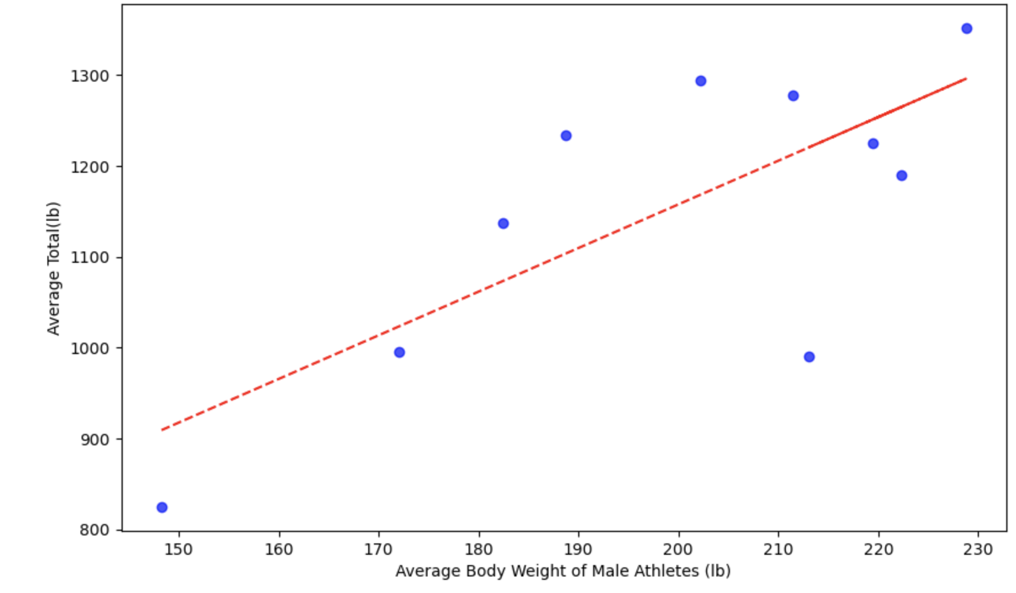

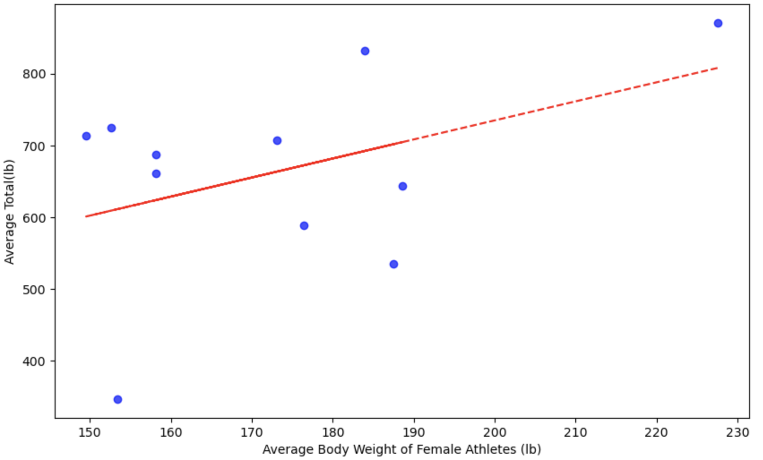

The last results we wanted to look deeper into was how bodyweight effects lifting. Our original hypothesis states that a higher body weight would correlate with being able to lift more weight. To test this, we took the total weight lifted between deadlift, bench press, and squat, and measured the average totals across all weight ranges that competed. Regardless of gender, there appears to be a correlation between weight and amount lifted. The results seem stronger for males, but this may be due to the lack of women in the sample size above 200Ib, so there’s less data to support that claim. But nonetheless, it appears to hold true as the highest weight, on average appears to lift the most total weight in competition.